Logo Here

Technical Documentation
Date: July 24, 2026, Version: 1.0
Revision History
Version | Date | Author | Description
1.0 | 20-july-2026 | Snehal Ann Alva | Initial draft

Table of Contents
Technical Documentation 1
1. Introduction 1
1.1 Purpose 1
1.2 Scope 1
1.3 Intended Audience 1
1.4 References 1
1.5 Acronyms and Definitions 2
2. System Overview 2
2.1 High-Level Architecture 2
2.2 System flow - Key Components 2
2.3 User Roles and Access Levels 2
3. Functional Requirements 3
3.1 Module/Feature Name 3
3.2 Inputs/Outputs 3
3.3 Business Rules 4
3.4 Error Handling 4
4. Non-Functional Requirements 4
4.1 Performance 4
4.2 Security 5
4.3 Availability 5
4.4 Maintainability 5
5. Data Model / Database Design 5
5.1 Entity-Relationship Diagram 5
5.2 Tables and Fields 6
5.3 Indexes and Keys 6
5.4 Sample Data 6
6. Integration Points 7
6.1 External Systems 7
6.2 APIs Used 7
6.3 Data Flow Diagram 8
6.4 Authentication/Authorization 8
7. Test Strategy 9
7.1 Test Scenarios 9
7.2 Expected Results 9
7.3 Traceability to Requirements 10
8. Deployment & Configuration 12
8.1 Environments 12
8.2 Setup Steps 12
8.3 Configuration Files and Parameters 14
9. Appendix 15
Glossary 15
Screenshots 16
Code Snippets 16
References 20

1. Introduction

1.1 Purpose
This document describes the AI Service Desk — a RESTful API backend for managing IT support tickets. It exists to:
- Serve as a technical reference for developers, QA, and stakeholders
- Document API endpoints, data models, middleware, and configuration
- Act as an onboarding guide for new team members
- Record the CORS policy and security configuration

1.2 Scope
- FastAPI app layers: API routes, services, models, schemas, core utilities
- Ticket lifecycle: create, list, get, update, close, delete
- Middleware: CORSMiddleware + X-Response-Time header
- Config via .env + pydantic-settings
- Async PostgreSQL via SQLAlchemy + asyncpg
- Alembic migrations, pytest + httpx testing

1.3 Intended Audience
List the stakeholders or roles expected to use this document (e.g., Developers, QA, Product Owners, Clients).
- Backend Developers - Contribute code, understand service & API layers
- QA / Test Engineer -Write tests against endpoints and CORS behavior
- Product Owners -Understand ticket business rules (e.g., closed ≠ reopenable)
- DevOps -Review DB config, .env, Docker setup
- Clients / Stakeholders -High-level scope overview

1.4 References
All references are real tools/files from your project: FastAPI, Starlette CORSMiddleware, SQLAlchemy 2.x async, asyncpg, Alembic, Pydantic Settings, pytest, httpx, pyproject.toml, .env, alembic.ini.

1.5 Acronyms and Definitions
Covers: API, ASGI, CORS, CRUD, ORM, UUID, JWT, FastAPI, Uvicorn, SQLAlchemy, asyncpg, Alembic, Pydantic, Starlette, X-Response-Time, Ticket, TicketNotFoundError, ClosedTicketError, open/closed statuses, priority, REST, HTTP, QA.

2. System Overview

2.1 High-Level Architecture
- Narrative + ASCII diagram showing the full request path: Client → Uvicorn → CORS Middleware → X-Response-Time → FastAPI Router → Pydantic Schema → TicketService → SQLAlchemy ORM → SQLite/PostgreSQL
- Mermaid architecture diagram with all components, their file locations, and connections

2.2 System flow - Key Components
- Sequence diagram showing exact step-by-step data flow for a full request/response cycle
- Component table covering all 9 layers: Entry Point, Middleware, API Routes, Schemas, Service, Exceptions, ORM Model, Database, Config
- Endpoint reference table with all 8 routes, methods, and HTTP status codes
- Ticket State Machine diagram — open → closed transition with the business rule that closed tickets cannot be reopened (enforced in TicketService)

2.3 User Roles and Access Levels
- Role definitions table: Anonymous, End User, Support Agent, Admin, Service Account
- Permission matrix per endpoint per
- Field-level access table showing who can set/edit which ticket fields

3. Functional Requirements

3.1 Module/Feature Name
Feature: Ticket Management Module
Purpose:
The Ticket Management module enables users to create, retrieve, update, filter, close, and delete support tickets. It acts as the core component of the service desk application by maintaining the complete lifecycle of a ticket.
Functionality:
- Create a new support ticket with title, priority, status, and optional assignee email.
- Retrieve all tickets or filter them by status and priority.
- Retrieve a specific ticket using its unique ID.
- Update ticket details such as title, priority, status, and assignee.
- Close an existing ticket.
- Delete a ticket from the system.
- Store all ticket information in a PostgreSQL database using SQLAlchemy ORM.

3.2 Inputs/Outputs
Create Ticket:
The module accepts the ticket title, priority, status, and an optional assignee email as input. It returns the newly created ticket along with its unique ID and timestamps.
List Tickets:
The module accepts optional status and priority filters as input. It returns a list of tickets that match the specified filters.
Get Ticket:
The module accepts a ticket ID as input. It returns the complete details of the corresponding ticket.
Update Ticket:
The module accepts a ticket ID and the fields to be updated as input. It returns the updated ticket information after the changes are saved.
Close Ticket:
The module accepts a ticket ID as input. It updates the ticket status to closed and returns the updated ticket details.
Delete Ticket:
The module accepts a ticket ID as input. It deletes the corresponding ticket from the database and returns a successful deletion response (HTTP 204 No Content).

3.3 Business Rules
- Every ticket must contain a valid title.
- New tickets are assigned a default status of open unless another valid status is provided.
- New tickets are assigned a default priority of medium unless specified.
- A closed ticket cannot be reopened. Attempting to change its status back to open raises a ClosedTicketError.
- Operations such as update, delete, or close can only be performed on existing tickets.
- Filtering is supported only using the available status and priority fields.
- Ticket data is persisted in the PostgreSQL database, ensuring it remains available after application restarts.

3.4 Error Handling
- If a requested ticket does not exist, a TicketNotFoundError is raised and returned as an appropriate HTTP error response.
- If an attempt is made to reopen an already closed ticket, a ClosedTicketError is raised.
- Invalid request data is validated using Pydantic, and validation failures return HTTP 422 Unprocessable Entity.
- Database transactions are committed only after successful operations; failures trigger rollback mechanisms to maintain data consistency.
- Exceptions are handled centrally by FastAPI, ensuring meaningful error responses are returned to API clients while preventing application crashes.

4. Non-Functional Requirements

4.1 Performance

The system should respond to normal API requests within two seconds under standard operating conditions. It should support multiple users and ticket requests without significant delay. Database queries should be optimized to retrieve and update ticket information efficiently. The /health endpoint should return a response quickly because it does not perform database operations.

4.2 Security
The system should validate all user input using Pydantic models before processing it. Authentication should verify the identity of users before allowing access to protected features. Authorization should ensure that users can only perform actions permitted by their assigned roles. Sensitive information, such as passwords and credentials, should be stored securely using environment variables and should not be hard-coded in the application. Communication between the client and server should use HTTPS to protect data during transmission. Database credentials and user data should be protected from unauthorized access.

4.3 Availability
The system should remain available during normal operating hours with minimal downtime. The /health endpoint should indicate whether the application is running, while the /ready endpoint should verify whether the application can connect to the database. If one application instance becomes unhealthy, the load balancer should stop sending traffic to that instance and redirect requests to healthy instances. Database backups and multiple application instances can be used to reduce the risk of service interruption and data loss.

4.4 Maintainability
The system should follow a layered architecture with separate router, service, repository, schema, and model components. This separation makes the application easier to update, test, reuse, and debug. Logging should be used to record errors and important application events. Automated tests should verify business rules and prevent existing features from breaking when changes are introduced. Database structure changes should be managed through Alembic migrations so that updates can be applied or rolled back safely.

5. Data Model / Database Design

5.1 Entity-Relationship Diagram

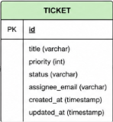

5.2 Tables and Fields

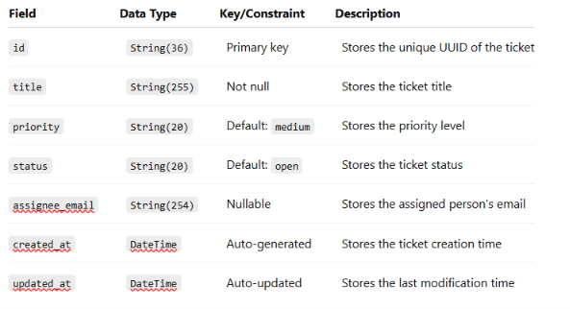

5.3 Indexes and Keys

The id field is the primary key of the tickets table. It ensures that every ticket has a unique identifier and supports efficient ticket retrieval. The database automatically creates an index for the primary-key field. Additional indexes can be created on frequently searched fields such as status, priority, and assignee_email to improve filtering performance.
The current table does not require a foreign key because it does not directly reference another table. Foreign keys can be added later when separate tables are introduced for users, departments, ticket comments, or ticket assignments.

5.4 Sample Data

INSERT INTO tickets (title, priority, status, created_at, updated_at) VALUES
('Database Connection Timeout', 5, 'open', NOW(), NOW()),
('Printer Jam Server Room', 2, 'in_progress', NOW(), NOW()),
('Password Reset Assistance', 1, 'resolved', NOW(), NOW());

6. Integration Points

6.1 External Systems
The application integrates with a PostgreSQL database to store and manage ticket information permanently. SQLAlchemy is used to communicate with PostgreSQL through application models and repository functions. Alembic integrates with the database to create, update, and roll back database schema changes. The application can also be connected to monitoring systems through its /health and /ready endpoints.

6.2 APIs Used

HTTP Method | Endpoint Path | Description
GET | / | Root API welcome message
GET | /health | Application health check
GET | /ready | Database readiness check
POST | /tickets | Create a new support ticket
GET | /tickets | List tickets (supports ?status= and ?priority= filters)
GET | /tickets/{id} | Fetch ticket by ID
PUT | /tickets/{id} | Update ticket attributes
POST | /tickets/{id}/close | Resolve support ticket
DELETE | /tickets/{id} | Permanently delete support ticket

6.3 Data Flow Diagram
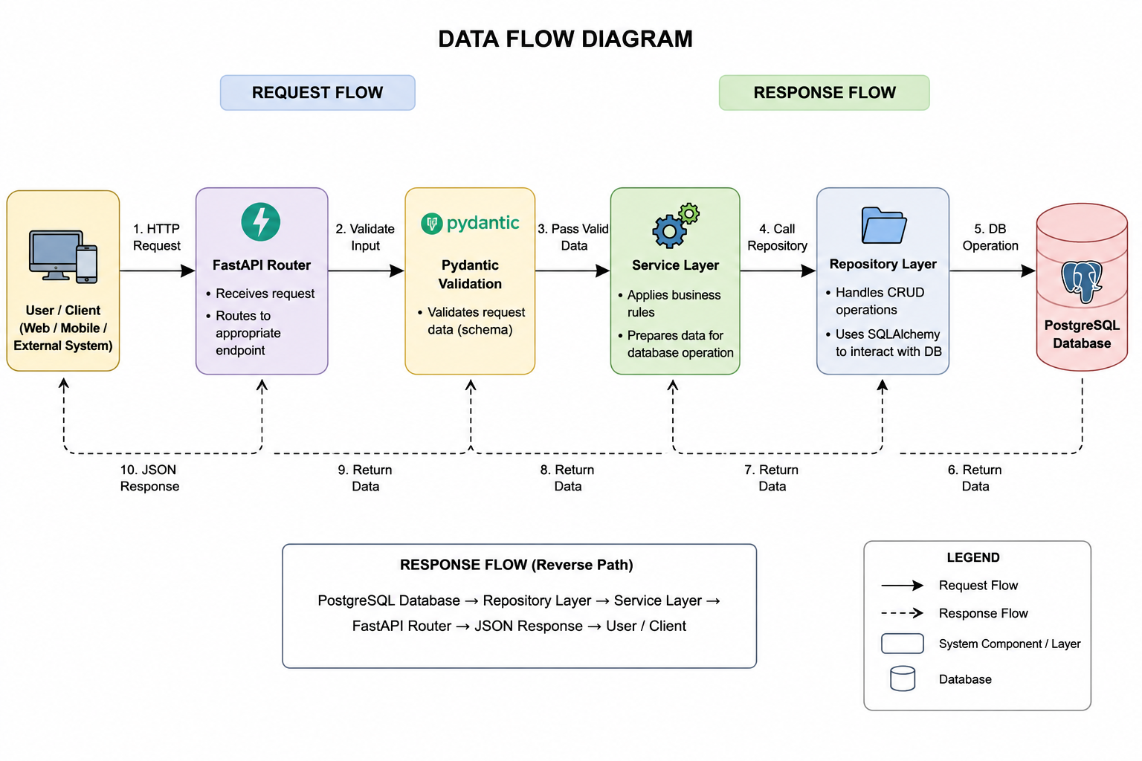

6.4 Authentication/Authorization
The current version of the application does not include a complete login or role-based authorization system. Therefore, the available API endpoints may be accessed without user authentication during development and testing.
In a production environment, authentication can be implemented using OAuth 2.0 or JSON Web Tokens. After a successful login, the user would receive an access token and include it in the authorization header of protected API requests. The application would validate the token before allowing access.
Role-based access control can be introduced to provide different permissions to administrators, support agents, and regular users. Administrators may create, update, close, and delete any ticket. Support agents may view and update assigned tickets, while regular users may create tickets and view only their own tickets. Passwords should be securely hashed, tokens should have expiration times, and all communication should use HTTPS.

7. Test Strategy

7.1 Test Scenarios
The test strategy covers ticket creation, retrieval, filtering, updating, closing, and deletion. Ticket creation tests verify that valid ticket details are accepted and stored correctly. Validation tests verify that invalid titles, unsupported status values, and incorrect priority values are rejected.
Ticket retrieval tests verify that all tickets can be listed and that a specific ticket can be retrieved using its ID. Filtering tests verify that tickets can be filtered by status and priority. Update tests verify that permitted ticket fields are modified correctly.
Closing tests verify that an open ticket can be changed to the closed status. Additional tests verify that a closed ticket cannot be reopened when this restriction is applied. Deletion tests verify that an existing ticket is removed successfully and that the correct error is returned for a missing ticket.
Health endpoint tests verify that the /health endpoint returns HTTP status code 200, contains the expected status value, returns JSON data, and includes the X-Response-Time header. Readiness tests verify that the /ready endpoint returns a successful response when the database is available and returns HTTP status code 503 when the database is unavailable.
Database tests verify that ticket information is committed after a successful operation. They also verify that failed database operations trigger a rollback. Performance tests confirm that lightweight endpoints respond within the defined response-time limit.

7.2 Expected Results
When valid ticket information is provided, the system should create a ticket and return its ID, title, priority, status, and timestamps. Ticket titles containing extra spaces should be trimmed before they are stored. When a priority value exceeds the permitted maximum, it should be handled according to the defined business rule.
A request to retrieve all tickets should return a list of stored ticket records. A request with valid status or priority filters should return only matching tickets. A request for an existing ticket ID should return the correct ticket, while a request for a missing ID should return a ticket-not-found error.
Updating a valid ticket should return the updated information. Closing an open ticket should change its status to closed. An attempt to reopen a closed ticket should be rejected. Deleting an existing ticket should return a successful response, while deleting a missing ticket should return an appropriate error.
The /health endpoint should return HTTP status code 200 with a JSON response such as {"status": "ok"}. The /ready endpoint should return HTTP status code 200 when the database connection is available and HTTP status code 503 when the connection fails. All successful API responses should use the expected JSON structure and status code.

7.3 Traceability to Requirements
Test ID | Test Scenario | Test Type | Requirement Covered | Expected Result
TC-01 | Create Ticket with valid data | Happy Case | Functional – Ticket Creation | Ticket is created successfully.
TC-02 | Retrieve all tickets | Happy Case | Functional – Retrieve Tickets | List of tickets is returned.
TC-03 | Retrieve ticket by valid ID | Happy Case | Functional – Retrieve Ticket | Correct ticket details are returned.
TC-04 | Update existing ticket | Happy Case | Functional – Update Ticket | Ticket is updated successfully.
TC-05 | Close an open ticket | Happy Case | Functional – Ticket Lifecycle | Ticket status changes to closed.
TC-06 | Delete existing ticket | Happy Case | Functional – Delete Ticket | Ticket is deleted successfully.
TC-07 | Create ticket with title length exactly 100 characters | Edge Case | Business Rule – Title Validation | Ticket is created successfully.
TC-08 | Create ticket with maximum allowed priority | Edge Case | Business Rule – Priority Validation | Ticket is created successfully.
TC-09 | Filter tickets when no matching records exist | Edge Case | Functional – Ticket Filtering | Empty list is returned.
TC-10 | Retrieve tickets from an empty database | Edge Case | Functional – Retrieve Tickets | Empty list is returned.
TC-11 | Create ticket with blank title | Failure Case | Business Rule – Title Validation | Validation error is returned.
TC-12 | Create ticket with invalid priority | Failure Case | Business Rule – Priority Validation | Validation error is returned.
TC-13 | Create ticket with invalid status | Failure Case | Business Rule – Status Validation | Validation error is returned.
TC-14 | Create ticket with invalid email format | Failure Case | Input Validation | Validation error is returned.
TC-15 | Retrieve ticket using invalid ID | Failure Case | Error Handling | 404 Not Found is returned.
TC-16 | Update non-existent ticket | Failure Case | Error Handling | 404 Not Found is returned.
TC-17 | Delete non-existent ticket | Failure Case | Error Handling | 404 Not Found is returned.
TC-18 | Reopen a closed ticket | Failure Case | Business Rule – Closed Ticket Restriction | ClosedTicketError is returned.
TC-19 | /health endpoint | Happy Case | Availability | Returns HTTP 200 with status: ok.
TC-20 | /ready endpoint when DB is available | Happy Case | Availability | Returns HTTP 200.
TC-21 | /ready endpoint when DB is unavailable | Failure Case | Availability | Returns HTTP 503.
TC-22 | Response time validation | Edge Case | Performance | Response time is within the defined limit.
TC-23 | Database rollback on failed transaction | Failure Case | Data Consistency | Transaction is rolled back successfully.
TC-24 | Router, Service, Repository, Schema, and Model unit tests | Happy Case | Maintainability | All unit tests pass successfully.

8. Deployment & Configuration

8.1 Environments
The Developer environment is the individual local workspace where developers write code, implement new features, fix bugs, and perform initial unit testing before committing changes to the shared repository.
The Development (Dev) environment is a shared environment where newly developed features are integrated and tested together. Developers perform integration testing and verify that the application works correctly with the database and other components.
The Quality Assurance (QA) environment is used by the QA team to verify application functionality, validate bug fixes, and execute integration, regression, and system testing. This environment ensures that new changes do not introduce defects before the application is moved to the next stage.
The User Acceptance Testing (UAT) environment is used by business users and stakeholders to validate that the application meets business requirements and behaves as expected under real-world scenarios. Only features approved during UAT are considered ready for production deployment.
The Production (Prod) environment hosts the live application and serves end users. It contains the final approved version of the application, and only thoroughly tested and validated releases are deployed to this environment to ensure high availability, reliability, and data integrity.

8.2 Setup Steps
Prerequisites
- Python: 3.10+ (Python 3.13 recommended)
- Terminal: PowerShell (Windows) or Terminal (Linux/macOS)

- git clone https://github.com/Snehal-goml/ai-service-disk.git cd Ai_Service_Desk folder
- Create Virtual Environment
Create a Python virtual environment named .venv
python -m venv .venv
- Activate Virtual Environment
Windows (PowerShell):
If script execution is restricted, set execution policy for the session first:
Set-ExecutionPolicy -Scope Process -ExecutionPolicy RemoteSigned
.\.venv\Scripts\Activate.ps1
Windows (Command Prompt / CMD):
.venv\Scripts\activate.ps1
(Once activated, your terminal prompt will display (.venv) at the beginning).
- Install Dependencies
Upgrade pip and install all required packages:
python -m pip install --upgrade pip
pip install -r requirements.txt
pip install pytest httpx
- Configure Environment Variables (.env)
Ensure a .env file exists in the root of ai-service-desk/:
- Run the Development Server
Start the FastAPI application with Uvicorn:
python -m uvicorn app.main:app --reload --host 127.0.0.1 --port 8000
- Interactive API Documentation (Swagger UI): http://127.0.0.1:8000/docs
- ReDoc Documentation: http://127.0.0.1:8000/redoc
- Health Check: http://127.0.0.1:8000/health
- Readiness Check: http://127.0.0.1:8000/ready
- Run Tests
To verify everything is working correctly, run pytest:
python -m pytest -v
- Run with Docker
Build Image:
docker build -t ai-service-desk .
- Run Container:
docker run -p 8000:8000 --env-file .env ai-service-desk
- Check if the container and image is present or not :
- Docker ps-containers
- Docker images
- Start Application Server:
uv run uvicorn app.main:app –reload
Interactive Swagger UI will be available at http://127.0.0.1:8000/docs.

8.3 Configuration Files and Parameters

The application uses a .env file to store environment-specific configuration values. This file contains parameters such as the database host, database port, database name, username, password, and application environment settings. Sensitive information is stored outside the source code to improve security.
The requirements.txt file lists all Python libraries required by the application. The pyproject.toml file defines project metadata and dependency configuration. The alembic.ini file and the Alembic migration scripts manage database schema versions and migrations. Configuration files should be updated separately for Development, QA, UAT, and Production environments to ensure that each environment connects to the correct database and uses the appropriate settings.

9. Appendix

Glossary
API (Application Programming Interface): A set of endpoints that allows applications to communicate with each other.
FastAPI: A modern Python framework used to develop high-performance REST APIs.
PostgreSQL: An open-source relational database management system used to store ticket information.
SQLAlchemy: A Python Object Relational Mapper (ORM) that simplifies database operations by mapping Python classes to database tables.
Alembic: A database migration tool used to create, modify, and manage database schema versions.
Pydantic: A Python library used for request validation and data serialization.
Repository Layer: The application layer responsible for performing database operations.
Service Layer: The layer that implements business logic before interacting with the database.
Router: The FastAPI component that receives HTTP requests and forwards them to the appropriate service.
ORM (Object Relational Mapping): A technique that allows database tables to be represented as Python classes.
HTTP Status Code: A numeric code returned by the server to indicate the outcome of an API request, such as 200 OK, 404 Not Found, or 503 Service Unavailable.

Screenshots

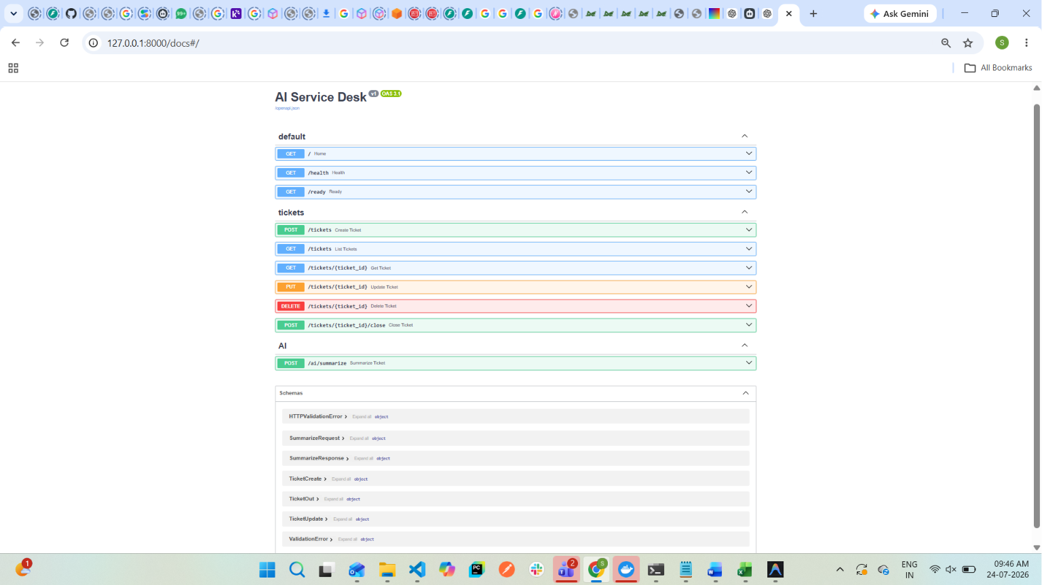
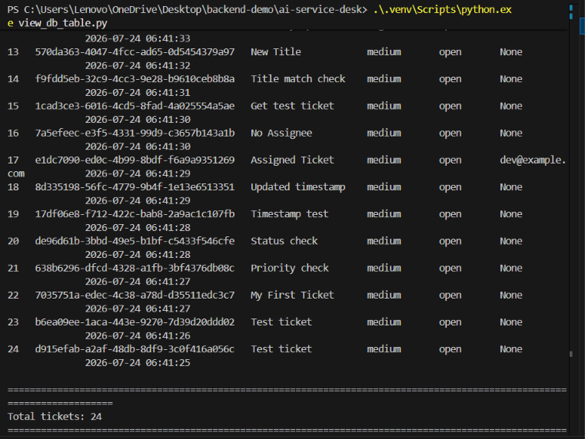
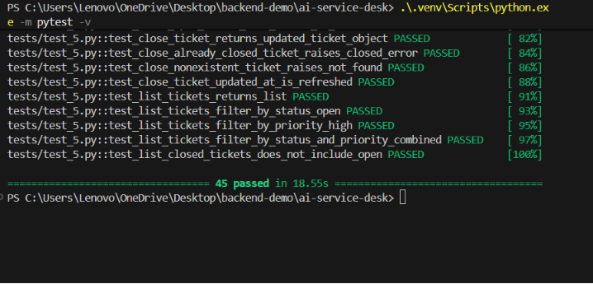
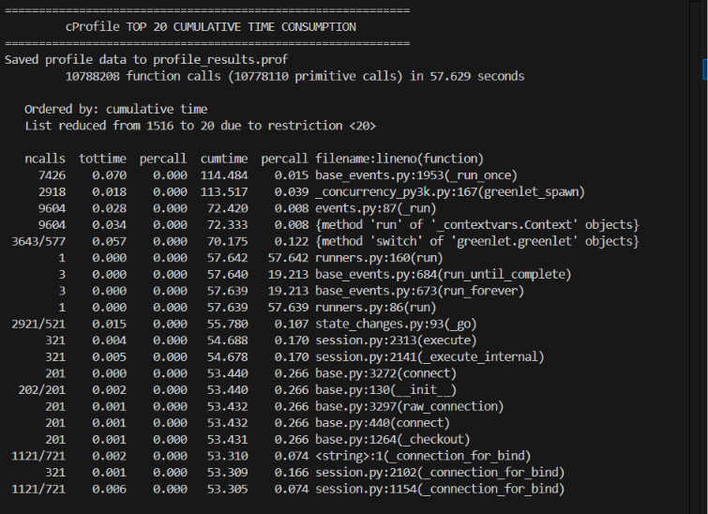
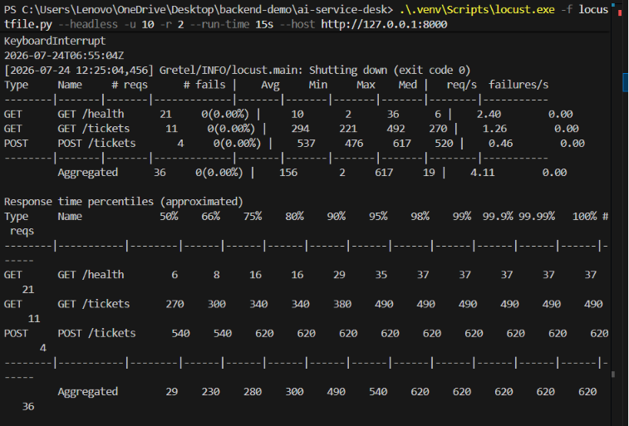
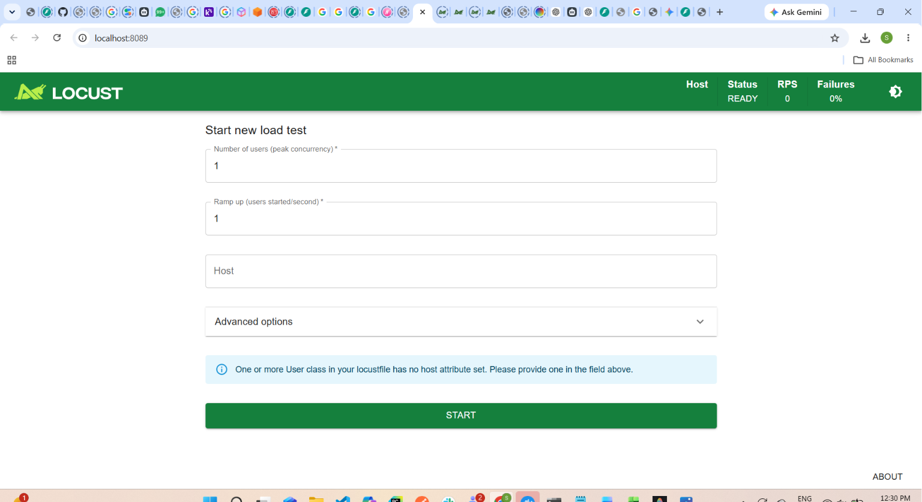
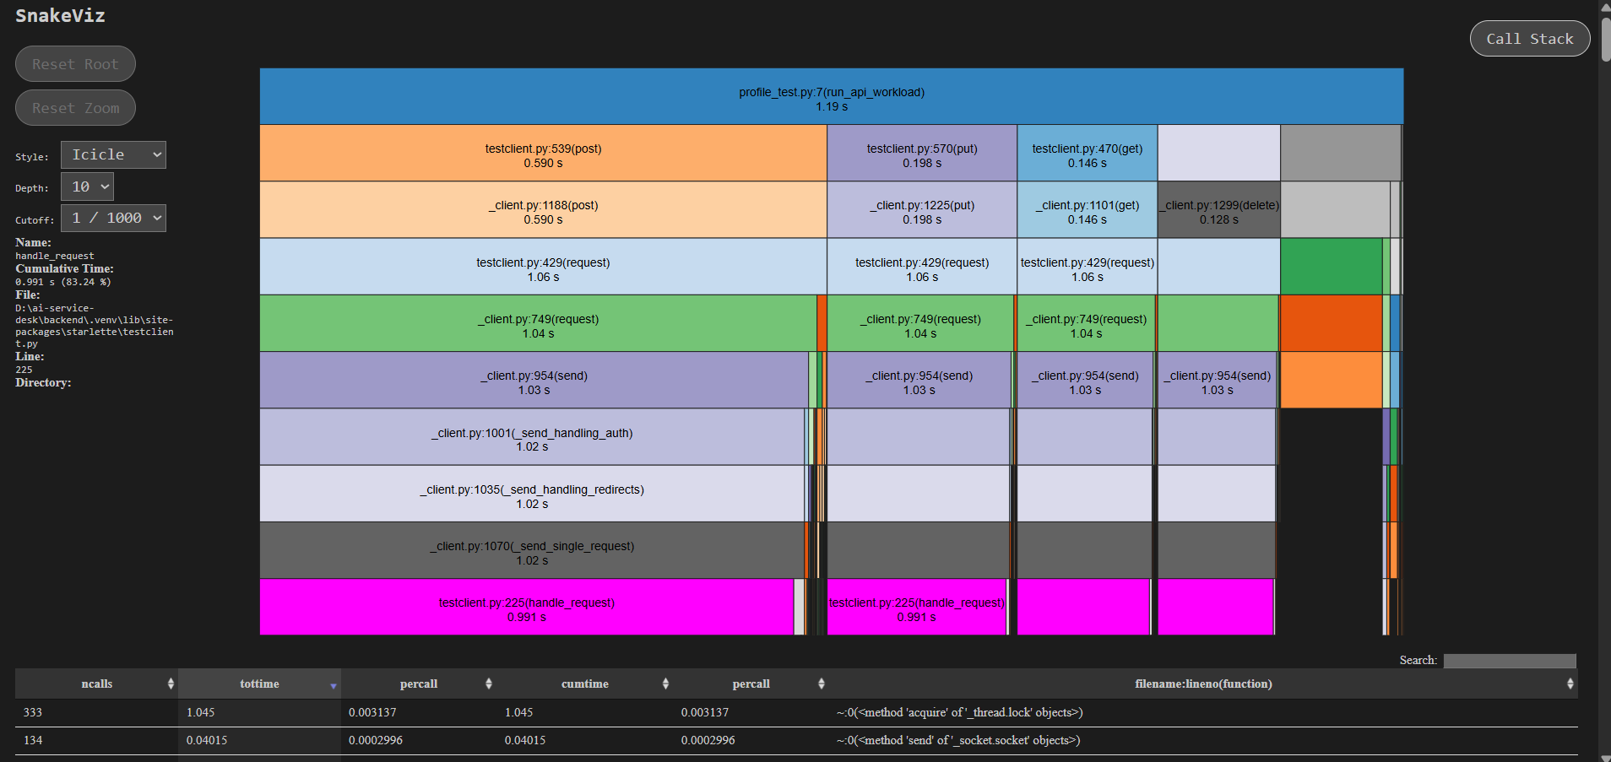

Code Snippets
Create Ticket API
POST /tickets
Content-Type: application/json
{
"title": "Unable to login",
"priority": 3,
"status": "open"
}
Health Check API
GET /health
Ready Check API
GET /ready
Sample SQL Query
SELECT *
FROM tickets
WHERE status = 'open';
Pydantic Validation Example
class CreateTicketRequest(BaseModel):
title: str
priority: int
status: str

References
The application was developed using the following technologies and documentation:
- FastAPI Official Documentation: https://fastapi.tiangolo.com/
- SQLAlchemy Documentation: https://docs.sqlalchemy.org/
- Alembic Documentation: https://alembic.sqlalchemy.org/
- PostgreSQL Documentation: https://www.postgresql.org/docs/
- Pydantic Documentation: https://docs.pydantic.dev/
- Pytest Documentation: https://docs.pytest.org/
- Uvicorn Documentation: https://www.uvicorn.org/
- Python Official Documentation: https://docs.python.org/

